
User Manual

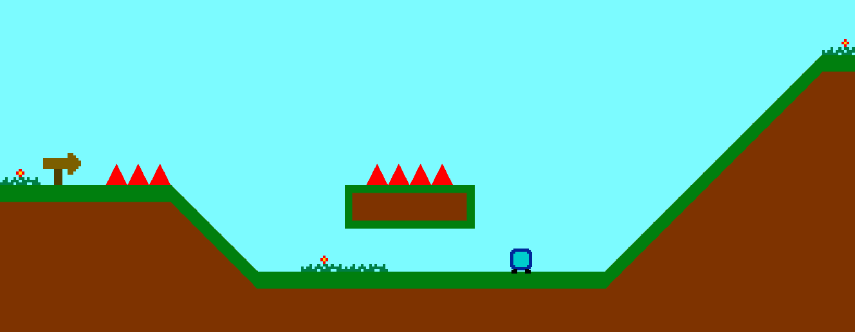

Table of contents
Quick Starter Guide 2
Movement 2
Spikes 2
Checkpoints 2
Moving Platforms 2
Options 3
Saving and Loading 3
Need Support? 3

Quick Starter Guide
Blueman is an easy game to play! Start the game, click play and get going! Dodge the spikes, jump to the next platform and try to reach a checkpoint! There is a total of nine checkpoints before you reach the finish line.

Movement
You can move Blueman by using the arrow keys. Use the left and right arrow keys to move left and right, and the up-arrow key to jump. Alternatively, you can use the A and D button on your keyboard to move left and right, and W to jump.

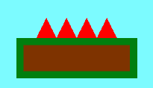
Spikes
Spikes are the red things you don’t want to touch. Touching one of these means you’ll have to start all over again (or go back to a checkpoint if you’ve already reached one).

There are moving spikes as well. They, as the name suggests move and are trickier to dodge.

Tip! Spikes move at a constant speed.


Checkpoints
Checkpoints are your best friends! Reaching a checkpoint means you won’t have to do the previous part again if you die.

Tip! Always save your game after you’ve reached a checkpoint!.

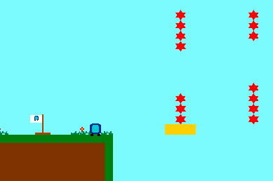
Moving Platforms
Moving platforms can bring you to places you otherwise wouldn’t be able to reach. They’ll take you with them and move you to the other side of the gap.

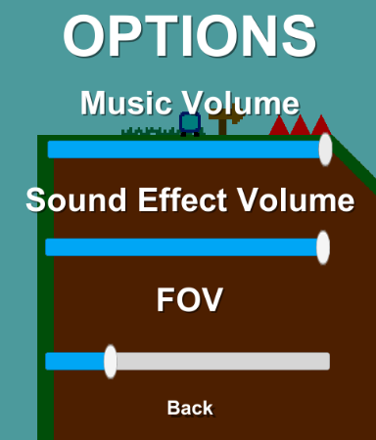
Options
There are some options for you to customize your game. You have three options:
- Music Volume: Change the music volume
- Sound Effect Volume: Change the volume for sound effects. Sound effects include the jumping, dying and checkpoint sounds.
- FOV: Change the size of your Field of View.

Saving and Loading
You can save and load your game in the menu. When saving your game, your last checkpoint will be saved. Please notice that your position will not be saved.

When loading your game, you will be teleported to the last checkpoint you reached when you saved your game.

Need Support?
For technical support, please visit www.finnalberts.nl/contact. If you ran into some kind of bug, please send along the log-file (output_log.txt), which can be found in: C:\Users\YOUR_
USERNAME_HERE\AppData\LocalLow\Finn Alberts\Blueman - Adventure Time. Please make sure you are playing the latest version of the game. The game version can be found in the bottom left corner of the title screen.

